Classful Addressing (Part 3)

Deciding whether given IP addresses and subnet masks are in the same network can communicate with each other using switches:

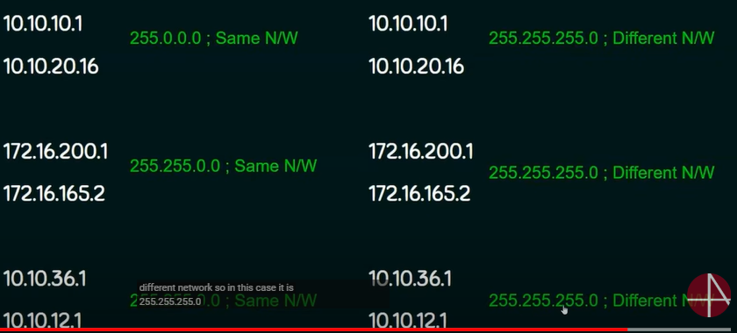

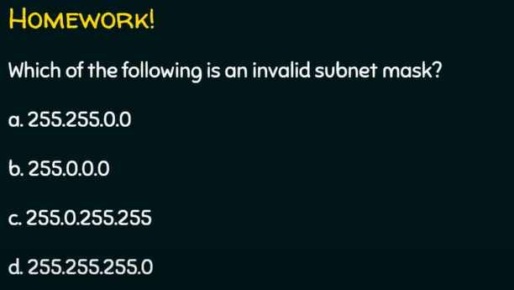

C is invalid